2 roles

1. Service requester
2. Service provider

Build

Use

Combine

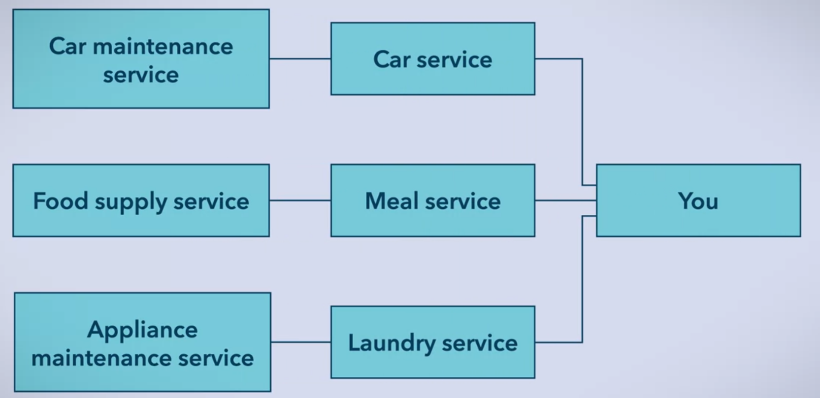

2 contexts

1. On the internet – external
2. In large organizations – internal

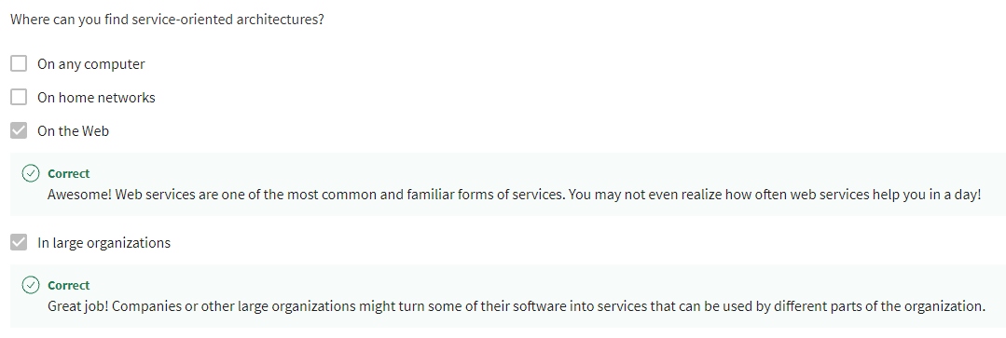

Web Services

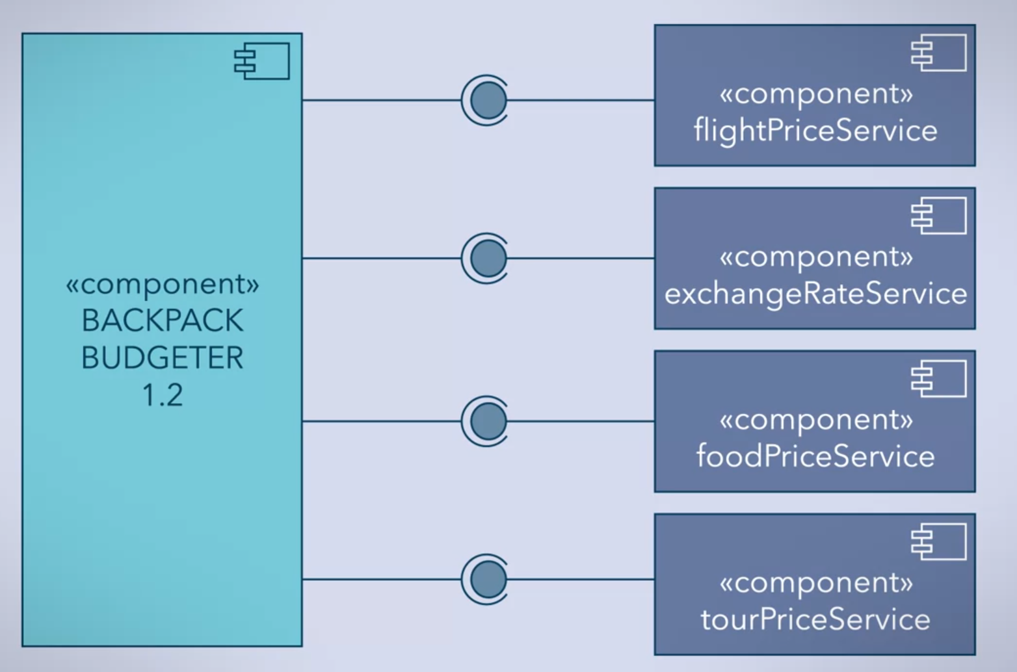

* Already available services

In large enterprises/organization

* In house code

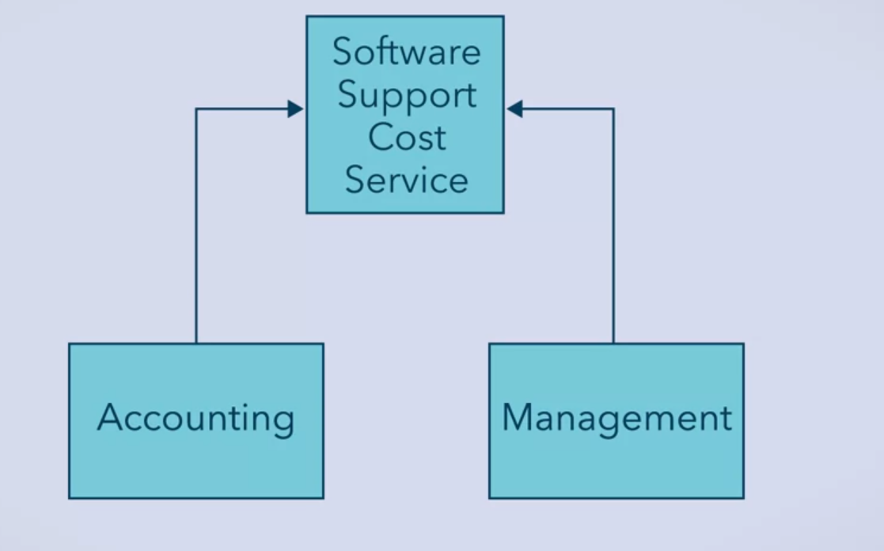

Service-Oriented Architecture (SOA)

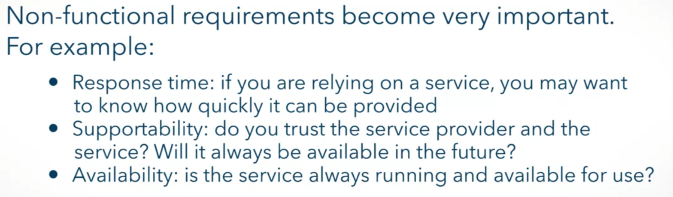

Modularity

Extensibility

Code Reuse